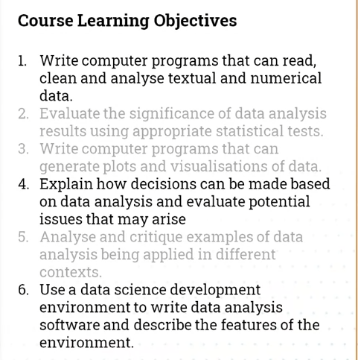

## Summary

